**Microscope Assessment**  Name: ____________________ /41

|  |  |  |
| --- | --- | --- |
| Task | Available mark | Your mark |
| Microscope carried correctly | 1 |  |
| Microscope tube/ Barrel lowered while looking from side | 1 |  |
| Microscope light and mirror set up correctly | 1 |  |
| Start on Low power | 1 |  |
| Use coarse focus before fine focus | 1 |  |
| Switch to higher objective lens while looking from side | 1 |  |
| Do not adjust barrel when changing lenses, use fine focus after switching to higher magnification | 1 |  |
| Diagram has appropriate title | 1 |  |
| Diagram is drawn in pencil | 1 |  |
| Diagram is neat (no shading, nice and clear lines) | 1 |  |
| Total magnification is written on diagram | 1 |  |
| Nucleus, cell membrane and cytoplasm is labelled on diagram | 3 |  |
| **Total mark** | **14** |  |

**Fill in the missing spaces.**

Always carry a microscope with one hand holding the arm and the other under the ____________.

To work out the total magnification, _______________ the magnification of the ocular lens by the magnification of the objective lens being used.

What would be the total magnification if the ocular magnification is 10x and the objective lens is 4x? ___________

What would be the total magnification if the ocular magnification is 10x and the objective lens is 10x? ___________

**Write the part of the microscope next to the correct description.**

Used to move the microscope tube up and down. ________________________

Used to make fine adjustments on the focus. ________________________

The bottom of the microscope, used for support. ________________________

Connects the ocular lens to the objective lenses. ________________________

Holds the slide in place on the stage. ________________________

Combination of lenses at the viewing end of optical instruments. ________________________

Small platform where the specimen is mounted for examination. ________________________

Part of microscope that you look through. ________________________

Used to direct light up underneath the stage. ________________________

*Barrel, stage clips, fine focus knob, coarse focus knob, mirror, stage, objective lenses, base, ocular lens*

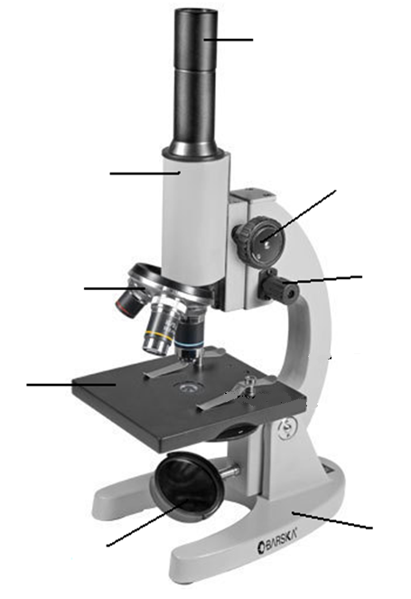

**Label the microscope diagram.**

**Fill in the blanks on the following table:**

|  |  |
| --- | --- |
| **mm** | **um** |
| 0.5 |  |
|  | 600 |
|  | 48 |
| 0.25 |  |

What does mm stand for?

What does um stand for?

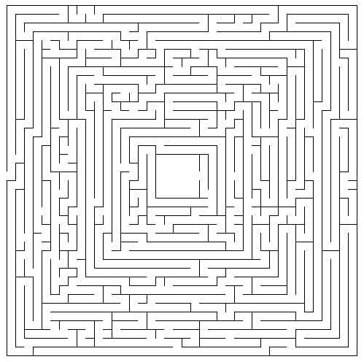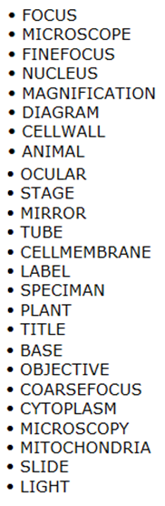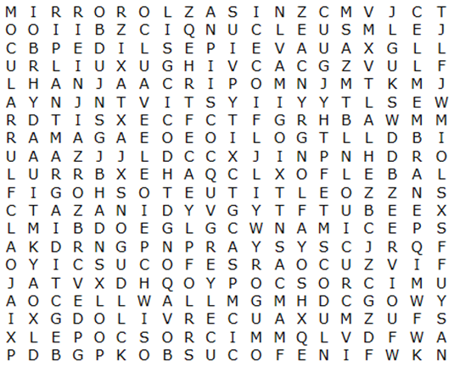

This page is not being assessed